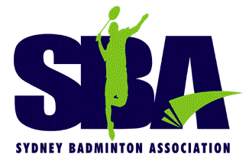
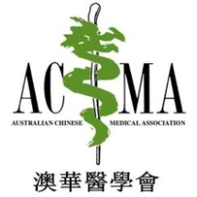
JOINLY ORGANISED BY

PROUDLY SPONSORED BY
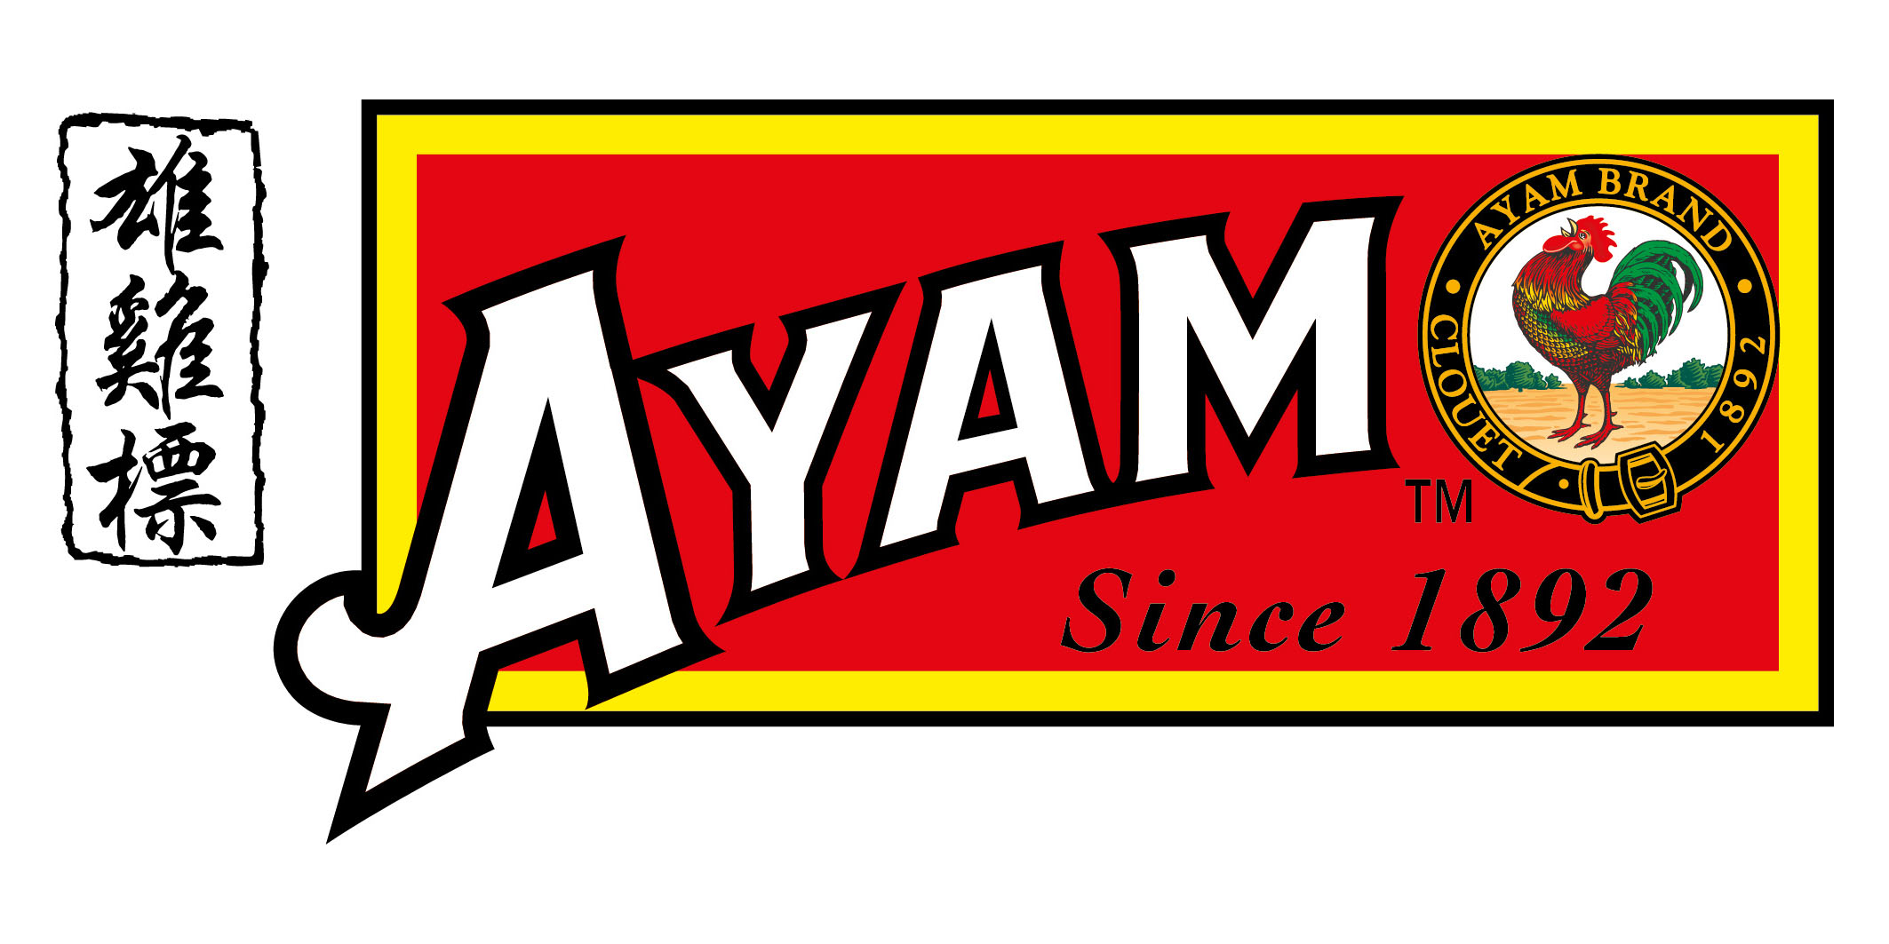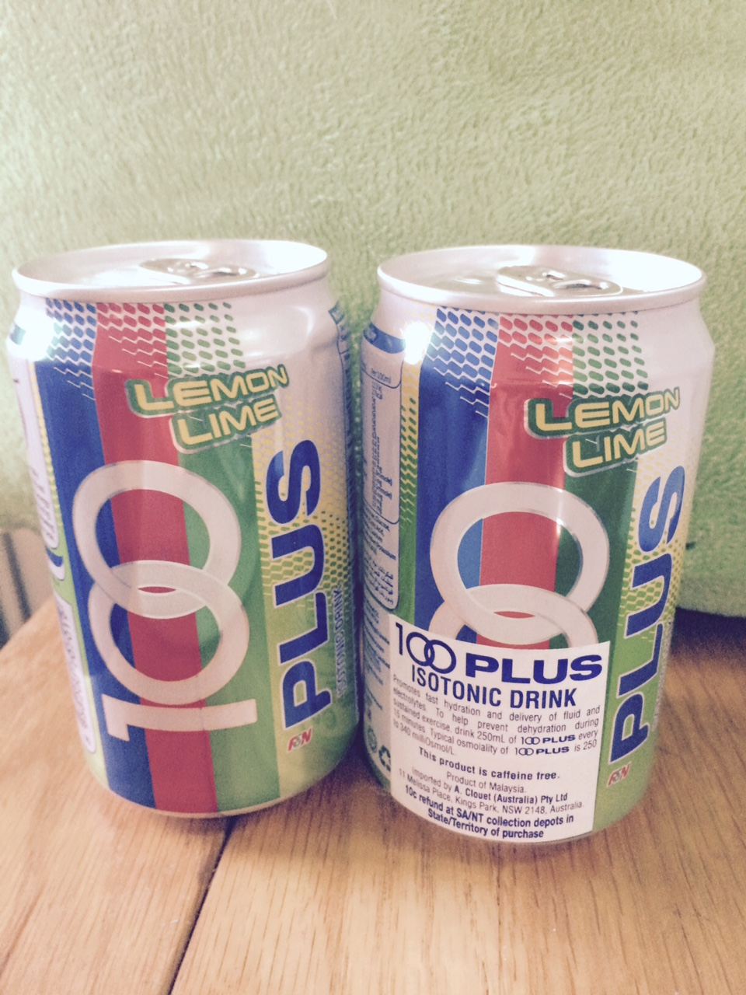
BADMINTON ENHANCEMENT CLASS
VENUE: ABDC - 8 Figtree Drive, Sydney Olympic Park NSW
Date: 6th Aug., 16 – 29th Oct, 16 (3 months) except 13/Aug; 10/Sep; 1/Oct
Time: Saturdays 1:30 pm – 5:00 pm (3.5 hours)
Class size: 20 – 25 person (limited seats - first come first serve basis)
Course Fee: SBA/ACMA Member $390* / Non-member $590*
PARTICIPANTS – who has finished SBA Beginners Class or eager to play SBA D Grade competition
ENROLMENT FORM
First Name: __________________ Last Name: __________________________________
Address: ________________________________________________________________
Email Address: ___________________ Contact Phone: _________________________
SBA/ACMA Membership No. ______________ or write membership in processing ______
(SBA Club name): _______________________________________
No. of Years of playing badminton: _________________________
Payment made EFT/cheque: $___________ paid on ___________ (ref. your name end “ELC”)
Please email back to sbaacctmaintance@gmail.com with payment receipt
Sydney Badminton Association St George Bank BSB 112-879 Account No.464 529 172
For Office use:- ___________________ Payment Checked: _______________
REFUND COURSE FEE - M $100/ NM $100 FOR PARTICIPANT WHO HAS
* met 80% CLASS ATTENDANCE AND NOT LATE IN CLASS
* PASS THE PRACTICAL TEST AT END OF THE COURSE

